|  |
| --- |
| Team Name Here |
| Project Title Here |
|  |

|  |
| --- |
| Team Member 1, Email Address  Team Member 2, Email Address  Team Member 3, Email Address  .....  ...  . |

# Project Feasibility

## Market Research & Product Background

Analysis of the existing market place with justification of genre, platform and proposed content. Demonstrate that your project choice is the result of informed decision making and planning.

## Target Audience

Who the game is aimed at ? How have you justified this decision ? What evidence is there to suggest your decisions are well informed ?

## License/Brand Analysis

A study of the license and brand elements potential of the game. Give consideration for new franchise potential and an analysis of existing materials to avoid copyright and legal issues.

## Statement of Differentiation

Statement of differentiation - how and why is your product unique i.e. not a copy of an existing product ?

# Game Design Documentation

## Detailed Game Concept

A more in depth look at the concepts outlined in your original project proposal document. Key story elements, genre, narrative and product features.

## Game & Product Structure

Describe the key areas of your game such as levels & locations along with all game menus and sub-features. How exactly will areas of play be broken down ? How are they related ? How will the player move from one element to another (including menu and feature navigation).

## Gameplay Mechanics

A more in depth explanation of the mechanics that define your game play. This should consider everything from user input characteristics, to weapon systems, camera systems and objective tracking.

## Gameplay Goals & Challenges

A detailed overview of the required victory conditions and how it can be attained. Include any puzzle mechanics and physical challenges that apply.

## Product Asset List

Provide a definitive and descriptive list of all elements including story, characters, objects and locations, FX, SFX etc. Try to be as descriptive as possible here.

# Technical Design Documentation

## Key Technical Challenges

Give an overview of the expected technical challenges and development risks related to the proposed project.

## Workflow & Dependencies

Provide a breakdown of as many game features as possible, sorted by priority and task dependency. This should be completed for each major team role i.e. programming, technical art, audio etc.

## Technology & Applications

Provide a detailed breakdown of all core technologies that will be used during the development of the project. You should specify the exact version of the engine you are using, and list any critical plugins that may be required. You should also give consideration to hardware such as VR or other specific forms of input/display devices that your game may require use of.

## Technology Implementation Overview

Provide a written overview of all technical feature of your game. You should provide an explanation of how each feature was implemented and an overview of its architecture. This should be completed for ALL functioning parts of your game wherever possible.

# Art Style Documentation

## Key Visual Design References: Game Assets

Based on the Asset List you provided in section 2.5, provide an initial concept design for as many of the items as possible. This can then be used to further develop the “look and feel” of all objects within your game. Some examples images are as follows:

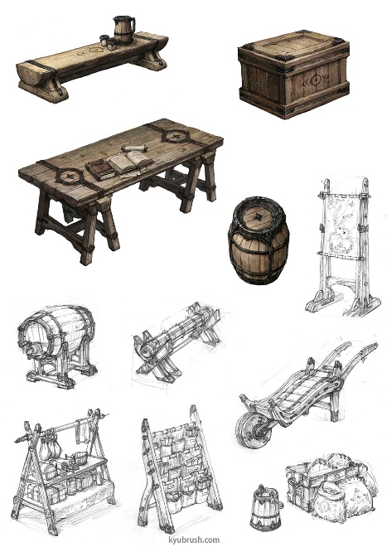 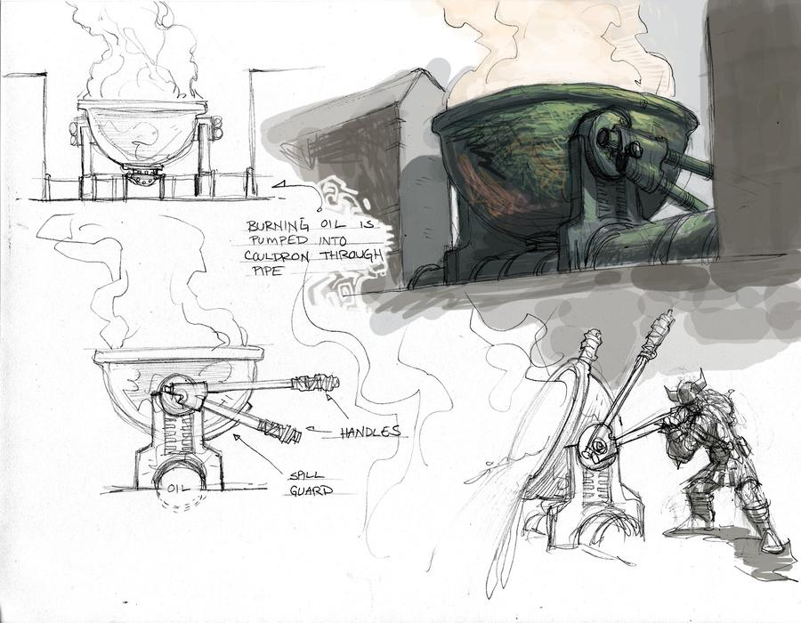

## Key Visual Design References: Environment Art

In reference to the game structure information you provided in section 2.2, provide some initial layout and map designs that will be used to further the development of your scenes. Try to give some consideration for style and mood. A basic example of map design is as follows:

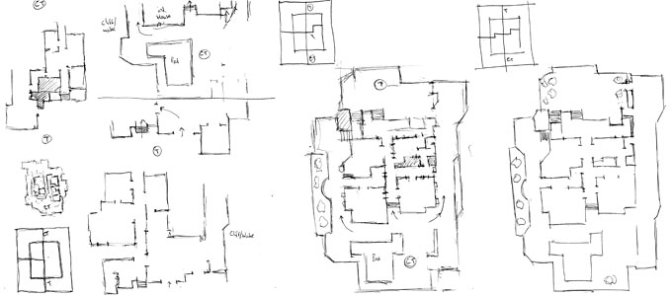

# Pendulum Analysis Documentation

## Core Game Loop Design

The core game loop involves the acquisition of items scattered throughout the environment and the interaction of the player with those items. The players’ goal is to solve a crime scene by interacting with the items gathered. Every item in an environment will be able to be picked up. It is the players choice to use reasoning and acquire the correct items. Feedback will be provided to the player through menus and dialogue boxes. Progress will be measured by the certainty of the character that they have come to the correct conclusion.

## Real-Time Engagement Design

The second to second engagement of the game requires the player to interact with items and choose how to examine them. The choice of how to examine items will be informed by their knowledge of crime scene investigation.

In a minute to minute gameplay loop, the player will need to make a string of correct choices in order to reach the desired outcome of solving a crime scene. The aim is to make no mistakes, which will drive the players engagement and pull their attention due to the desire to succeed.

## Long Term Engagement Model

A play session may last hours if the player wants to correctly solve a crime scene by replaying or if they want to play multiple scenarios. Each scenario can be scored based on time and efficiency of finding the solution, to encourage replayability on an hour to hour basis. Achievements can be utilised to incentivise better scores.

Year to year engagement relies on the serious nature of the game and the use of the game as an education tool. By staying true to real life investigation methodologies, the game holds a lot of potential for replayability. By adding more scenarios as additional content, players are drawn back by the potential of learning more about crime scenes and their investigations.

# Project Management & Development Timeline

## Proposed Development Plan

Provide a draft development timeline for the project as a whole - include ALL aspects of work ranging from research, development, report and presentation areas. Semesters 1 and 2.

## Schedule of Meetings

Provide a detailed schedule of management meetings for semester 1 and 2. How will you address the key elements from your primary timeline outlined above ?

## Personal Development Plans

Provide a draft project plan for each team member - at this stage it **does not** have to cover the project from beginning to end, but **should** include a **detailed** breakdown of work for semester 1.

## Initial Sprint Management

Provide a detailed plan for your first project sprint. Include dates, estimates, task priorities and dependencies.